There are several datasets in the experiment used for performing model extraction attacks on Recurrent Models.

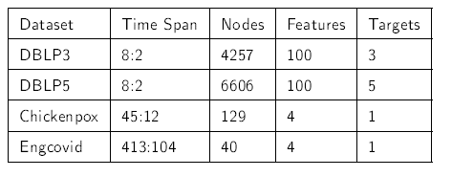

1. DBLP: In the dynamic node classification task, the attack on RGCN models has been performed on two types of DBLP datasets - DBLP5 and DBLP3. In those datasets, 6606 nodes in DBLP5 and 4257 nodes in DBLP3 represent bibliographic authors. 100 node features are achieved by implementing Word2Vec in authors' published paper information. Node targets refer to author classifications; authors in DBLP3 and DBLP5 are clustered into 3 and 5 unvaried classifications, respectively. Edges in dynamic graphs present whether authors have co-authorship in some papers. Figure 4 presents the first DBLP5 and DBLP3 graph snapshots whose layout follows a force-directed algorithm. DBLP3 is partitioned into DBLP3-A(2 snapshots as testing snapshots) and DBLP3-B (8 snapshots as training snapshots) for model training and extraction. DBLP5 is also partitioned into DBLP5-A(2 snapshots) and DBLP5-B(8 snapshots).
2. Chickenpox: this dataset presents a case of chickenpox in Hungary from 2004 to 2014; node features are the weekly count of chickenpox cases. The node target is the weekly number of cases for the upcoming week. The edge presents the neighborhood between two nodes. Chickenpox is divided into Chickenpox-A (45 snapshots) and Chickenpox-B(12 snapshots).
3. Engcovid: this dataset recorded reported cases of COVID-19 in England. Node features present the number of COVID-19 cases in the past few days. Node Targets are the number of cases the next day. Edges denote the population flow between every two regions. Engcovid is divided into Engcovid-A(413 snapshots) as a training dataset and Engcovid-B (104 snapshots) as a testing dataset.